In this video we will discuss **how to capture deadlock graph using SQL profiler.**  
  
   
  
To capture deadlock graph, all you need to do is add Deadlock graph event to the trace in SQL profiler.   
  
**Here are the steps :**   
**1.** Open SQL Profiler  
**2.** Click **File - New Trace**. Provide the credentials and connect to the server  
**3.** On the general tab, select **"Blank"** template from **"Use the template"** dropdownlist   
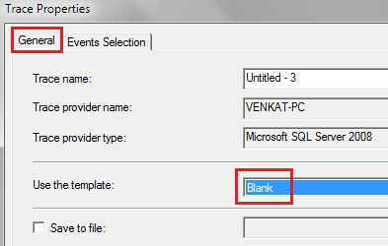   
  
**4.** On the **"Events Selection"** tab, expand **"Locks"**section and select **"Deadlock graph"**event   
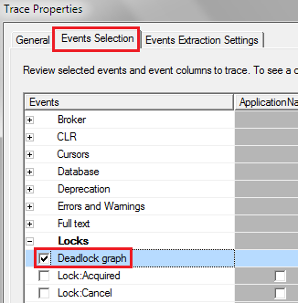   
  
**5.** Finally click the **Run**button to start the trace  
**6.** At this point execute the code that causes deadlock  
**7.** The deadlock graph should be captured in the profiler as shown below.   
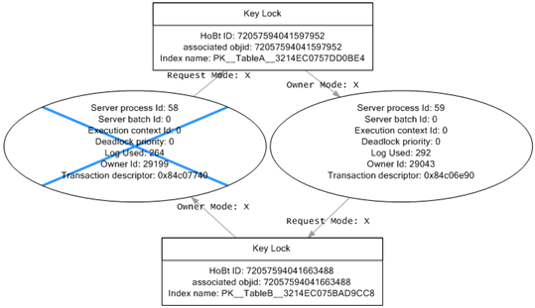   
  
**The deadlock graph data is captured in XML format.** If you want to extract this XML data to a physical file for later analysis, you can do so by following the steps below.  
**1.** In SQL profiler, click on **"File - Export - Extract SQL Server Events - Extract Deadlock Events"**  
**2.** Provide a name for the file  
**3.** The extension for the deadlock xml file is **.xdl**  
**4.** Finally choose if you want to export all events in a single file or each event in a separate file  
  
The deadlock information in the XML file is similar to what we have captured using the trace flag 1222.  
  
**Analyzing the deadlock graph**  
**1.** The oval on the graph, with the blue cross, represents the transaction that was chosen as the deadlock victim by SQL Server.  
**2.** The oval on the graph represents the transaction that completed successfully.  
**3.** When you move the mouse pointer over the oval, you can see the SQL code that was running that caused the deadlock.  
**4.** The oval symbols represent the process nodes

* **Server Process Id :** If you are using SQL Server Management Studio you can see the server process id on information bar at the bottom.
* **Deadlock Priority :**If you have not set DEADLOCK PRIORITY explicitly using SET DEADLOCK PRIORITY statement, then both the processes should have the same default deadlock priority NORMAL (0).
* **Log Used :**The transaction log space used. If a transaction has used a lot of log space then the cost to roll it back is also more. So the transaction that has used the least log space is killed and rolled back.

**5.** The rectangles represent the resource nodes. 

* **HoBt ID :** Heap Or Binary Tree ID. Using this ID query **sys.partitions** view to find the database objects involved in the deadlock.

SELECT object_name([object_id])

FROM sys.partitions

WHERE hobt_id = 72057594041663488

**6.** The arrows represent types of locks each process has on each resource node.